**THE WEATHER CONDITIONS, INCLUDING TEMPERATURE, HUMIDITY, WIND SPEED, AND PRESSURE**

**Submitted by:**

Satabdi Biswas

Batch No: 43

Roll: 01-043-19

**Submitted to:**

Md. Erfan

Assistant Professor & Chairman

Dept. of Computer Science & Engineering

University of Barishal

**Contents**

1. **Introduction........................................................................... 3**
2. **Dataset................................................................................... 3**
3. **Methodology.......................................................................... 4**

* **Data Collection........................................................................... 4**
* **Analysis Approach...................................................................... 4**
* **Visualization............................................................................... 4**

1. **Results.................................................................................... 5**

* **Temperature and Humidity Trends............................................. 5**
* **Wind Characteristics................................................................... 6**
* **Pressure Stability........................................................................ 7**
* **Dew Point and Fog Formation**........................................................ 7

1. **Conclusion.............................................................................. 8**
2. **Reference............................................................................... 9**
3. **Introduction:**

This report provides an analysis of weather data collected on January, 2023, over a 12-hour period. The data includes temperature, dew point, humidity, wind characteristics, pressure, precipitation, and weather conditions. The primary goal is to observe trends in temperature, humidity, and other parameters to identify key patterns that could influence weather conditions, particularly the prevalence of fog.

#### Dataset:

The dataset contains the following fields:

* **Date and Time**: Timestamp for the recorded data.
* **Temperature (°F)**: Ambient air temperature in Fahrenheit.
* **Dew Point (°F)**: Temperature at which air reaches saturation.
* **Humidity (%)**: Percentage of moisture in the air.
* **Wind**: Direction and condition of wind (e.g., calm or directional).
* **Wind Speed (mph)**: Wind speed in miles per hour.
* **Wind Gust (mph)**: Maximum wind speed recorded during the interval.
* **Pressure (in)**: Atmospheric pressure in inches of mercury.
* **Precipitation (in)**: Measured precipitation in inches.
* **Condition**: Descriptive weather condition (e.g., fog).

1. **Methodology:**
   1. **Data Collection**: The data was recorded automatically at 30-minute intervals on January 1, 2023. Observations were made regarding the temperature, dew point, humidity, wind speed, and other related weather parameters.
   2. **Analysis Approach**:

* **Temperature and Humidity Relationship**: We analyzed how temperature variations throughout the day impacted the humidity levels.
* **Wind and Humidity**: The wind speed and direction were also examined to see if they had any noticeable effects on humidity.
* **Pressure and Precipitation**: Variations in atmospheric pressure and their possible effects on precipitation and humidity were also observed.
  1. **Visualization**: Data trends for temperature, humidity, and other variables were plotted across the 24-hour period to identify patterns.

The dataset was analyzed to observe trends and relationships between variables such as:

1. Temperature and humidity levels over time.
2. Variations in wind direction and speed.
3. The relationship between atmospheric pressure and fog.
4. Patterns in dew point and its relationship with ambient temperature.
5. **Results:**
   1. **Temperature and Humidity Trends**:
   * Temperature fluctuated between 59°F and 66°F during the observation period. The temperature ranged from 59°F to 66°F throughout the day. There was a slight decrease in temperature from the early morning (66°F at midnight) to the early afternoon (61°F at 12:30 PM).
   * Humidity ranged from 78% to 94%, with higher humidity levels occurring when temperatures dropped closer to the dew point.
   * Humidity levels were generally high throughout the day, ranging from 78% to 94%. The highest humidity levels were recorded from 4:00 AM to 7:30 AM (94%), aligning with lower temperatures (59°F to 61°F).
   * These trends align with typical foggy conditions, where high humidity and cooler temperatures promote condensation.
   * The dew point remained consistently high, which contributed to the high humidity observed, especially in the early hours of the day.

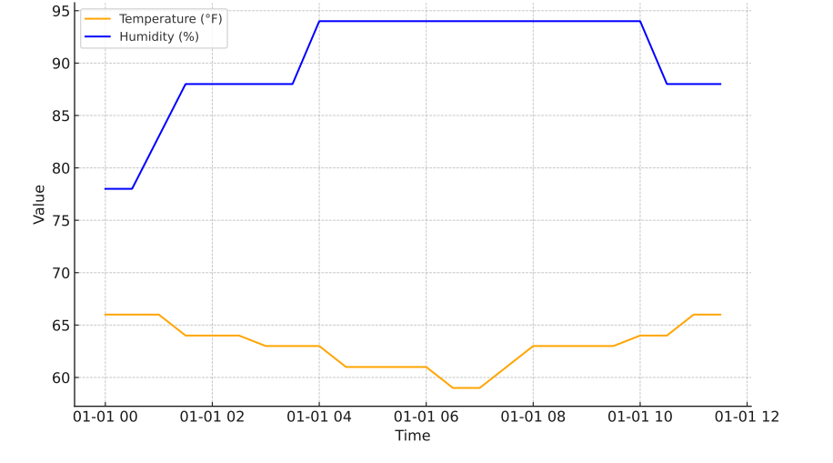

* 1. **Wind Characteristics**:

For most of the period, the wind was "calm," with speeds consistently at 0 mph.

Slight directional winds (ENE, NE, E, and ESE) and minor increases in speed (up to 6 mph) were observed intermittently.

Wind gusts were generally low, and the direction shifted slightly throughout the day (e.g., from CALM to NE and ESE). Wind conditions did not seem to significantly impact humidity levels but were steady during periods of high humidity.

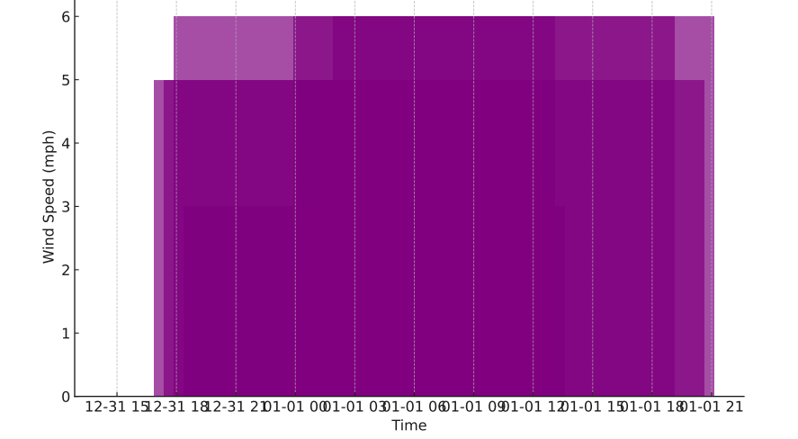

* 1. **Pressure Stability**:

Atmospheric pressure varied slightly, ranging from 30.00 to 30.12 inches. Higher pressures typically coincided with sustained foggy conditions.

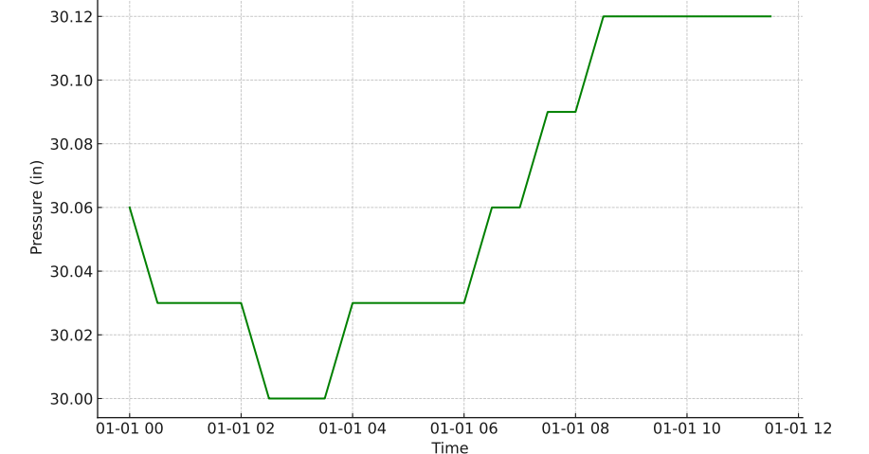

* 1. **Dew Point and Fog Formation**:

The dew point closely mirrored the temperature throughout, creating optimal conditions for fog formation due to air saturation.

There was no recorded precipitation, suggesting that the high humidity did not result in rainfall but rather in fog formation during the early hours.

1. **Conclusion:**

The dataset highlights the interplay of temperature, humidity, and pressure in maintaining foggy conditions. Key findings include:

* High humidity (near or at 94%) coupled with temperatures near the dew point promoted sustained fog.
* Calm winds or very light breezes contributed to fog persistence, as stronger winds typically disperse moisture-laden air.
* Minimal fluctuations in pressure ensured stability conducive to fog retention.

The data indicates that humidity levels remained consistently high, ranging between 78% and 94% throughout the day, with no significant variations tied to the slight temperature changes observed.

Wind conditions did not show a strong correlation with humidity, as calm periods and light winds were present during times of high humidity.

Atmospheric pressure remained stable, and no precipitation was recorded, supporting the presence of fog as the primary weather condition during the observation period.

Seasonal effects, particularly colder temperatures in the early morning, played a role in maintaining higher humidity levels.

This analysis underscores the importance of atmospheric conditions, such as humidity and dew point, in driving fog formation and persistence. These insights can aid in weather forecasting and understanding local climatic conditions.

Reference:

1. <https://www.kaggle.com/datasets/talhabu/bangladesh-weather-history>
2. ChatGpt.com
3. Uddin, Kabir; Matin, Mir A.; Meyer, Franz J. (January 2019). "Operational Flood Mapping Using Multi-Temporal Sentinel-1 SAR Images: A Case Study from Bangladesh". Remote Sensing. 11 (13): 1581. Bibcode:2019RemS...11.1581U. doi:10.3390/rs11131581.